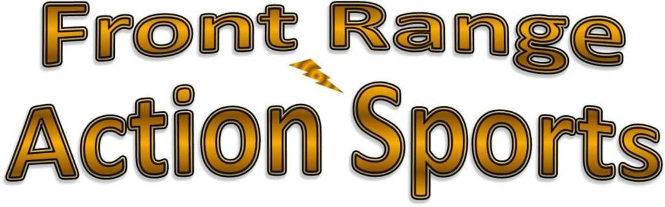

Invites *First Name* *Last Name*

To

Fish the Yakima River

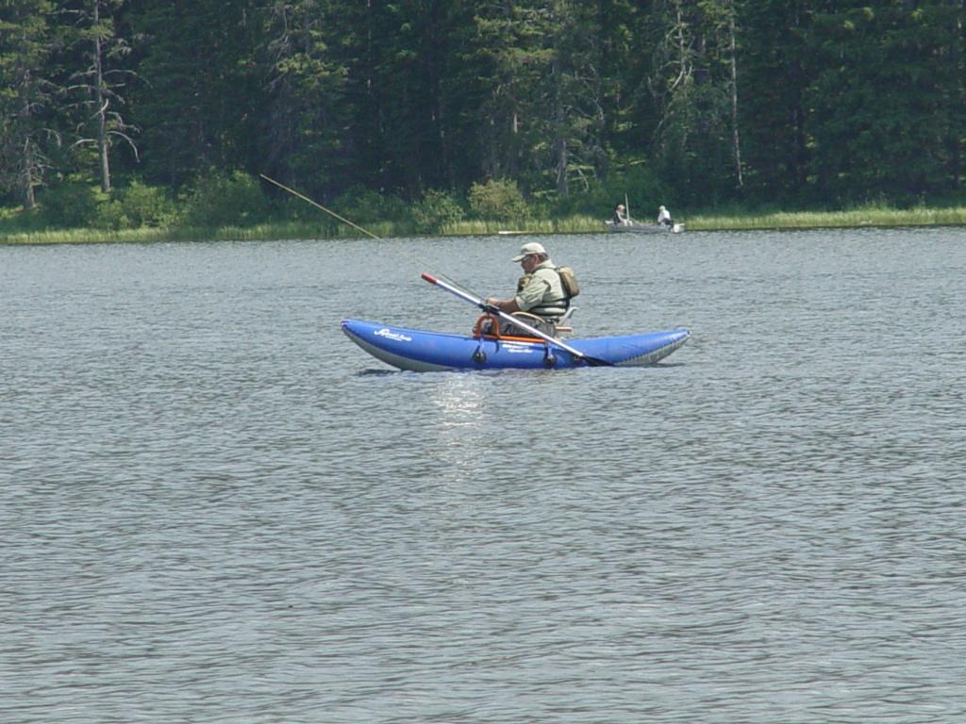Join our guides and enjoy some excellent fly fishing for wild trout on the Yakima River, the only Blue Ribbon trout stream in Washington State. We will be boarding a bus at 6:00 a.m. on Saturday, June 5. In Less than three hours, you’ll be casting your line in the river. We will boarding the bus to return to Front Range Action Sports at 3:30 p.m.

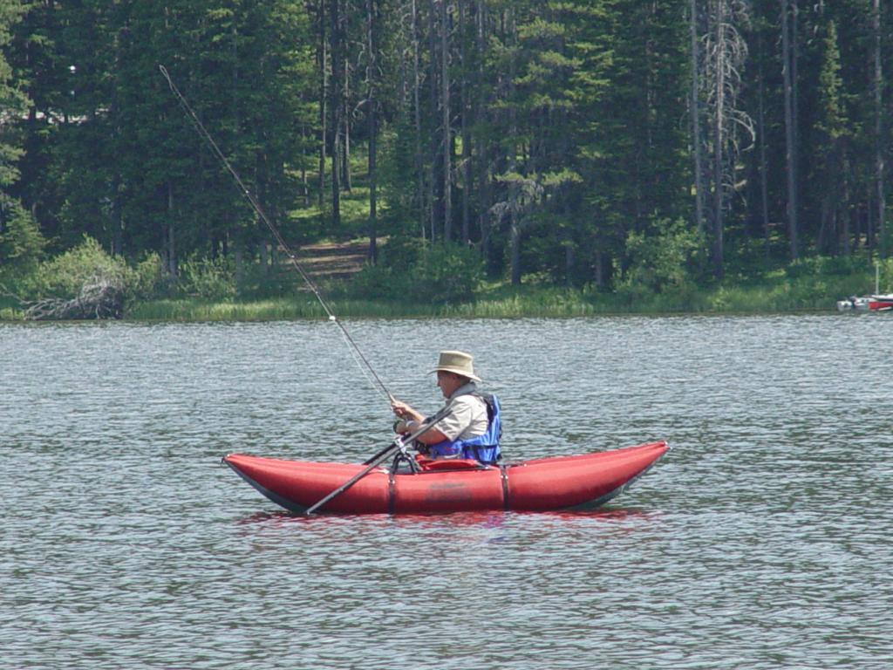The full-day trip includes transportation, guide service, boats, and lunch. The cost is $205 per person. Registration is limited, so book your trip today.

If you have questions, please call (206) 555-0021.